Flowchart in Programming

## Symbols Used in Flowcharts

Different symbols are used for different states in flowchart, for example: Input/Output and decision making has different symbols. The table below describes all the symbols that are used in making flowchart

| Symbol | Purpose | Description |
| --- | --- | --- |
| Flowline symbol in flowchart of programming | Flow line | Used to indicate the flow of logic by connecting symbols. |
| Terminal symbol in flowchart of programming | Terminal(Stop/Start) | Used to represent start and end of flowchart. |
| Input/Output symbol in flowchart of programming | Input/Output | Used for input and output operation. |
| Processing symbol in flowchart of programming | Processing | Used for arithmetic operations and data-manipulations. |
| Decision making symbol in flowchart of programming | Decision | Used to represent the operation in which there are two alternatives, true and false. |
| On-page connector symbol in flowchart of programming | On-page Connector | Used to join different flowline |
| Off-page connector symbol in flowchart of programming | Off-page Connector | Used to connect flowchart portion on different page. |
| Predefined process symbol in flowchart of programming | Predefined Process/Function | Used to represent a group of statements performing one processing task. |

### Examples of flowcharts in programming

**Draw a flowchart to add two numbers entered by user.**

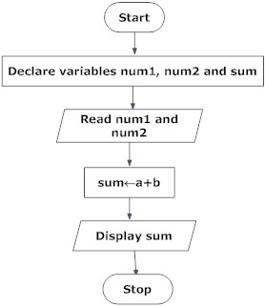

**Draw flowchart to find the largest among three different numbers entered by user.**

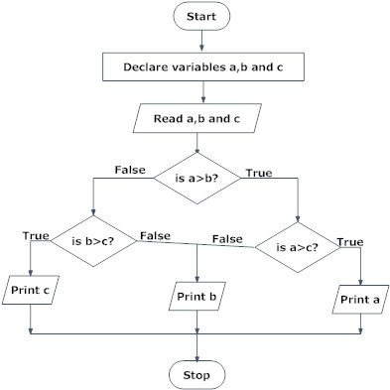

**Draw a flowchart to find all the roots of a quadratic equation ax2+bx+c=0**

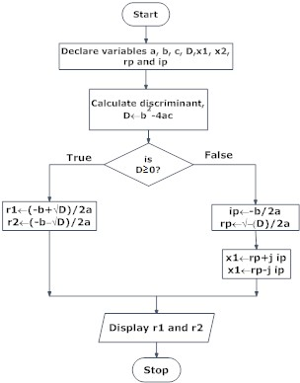

**Draw a flowchart to find the Fibonacci series till term≤1000.**

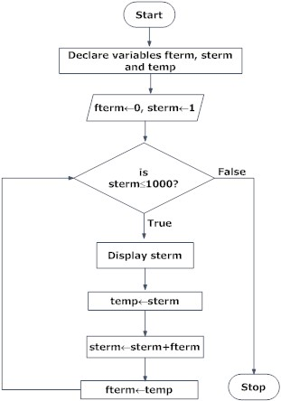

Though, flowchart is useful in efficient coding, debugging and analysis of a program, drawing flowchart in very complicated in case of complex programs and often ignored.

Programming Flowchart Template

<https://d2slcw3kip6qmk.cloudfront.net/marketing/pages/chart/examples/flowchart-templates/programming-flowchart.svg>

# Ultimate Flowchart Tutorial (Complete Flowchart Guide with Examples)

Updated on: 19 September 2018 https://creately.com/blog/diagrams/flowchart-guide-flowchart-tutorial/

So you want to learn flowcharts? Well, this flowchart tutorial will teach you all you need to know. It will cover the history of flowcharts, flowchart symbols, how to [create flowcharts](https://creately.com/diagram-type/flowchart?utm_source=flowtute&utm_medium=blog&utm_campaign=tutorialposts), flowchart best practices and we’ve also included a section to answer frequent questions about flowcharts. Best of all you can use our [flowchart software](https://creately.com/Flowcharts-and-Workflow-Diagrams-Online?utm_source=flowtute&utm_medium=blog&utm_campaign=tutorialposts) to draw them.

Creately already has some really awesome articles covering various things related to flowcharts like Meanings of flowchart symbols, how to use swim lanes in flowcharts, flowchart best practices, case studies and much more. This blog post will simply gather all that information and present them in a logical way. I’ve added links to different sections to make it easier to navigate. Click on the relevant link to quickly read the relevant section.

* [History of Flowcharts](https://creately.com/blog/diagrams/flowchart-guide-flowchart-tutorial/#FlowchartHistory)
* [Flowchart Symbols Meaning](https://creately.com/blog/diagrams/flowchart-guide-flowchart-tutorial/#FlowchartSymbols)
* [How to Draw a Flowchart](https://creately.com/blog/diagrams/flowchart-guide-flowchart-tutorial/#HowToDrawFlowchart)
* [Flowchart Templates and Examples](https://creately.com/blog/diagrams/flowchart-guide-flowchart-tutorial/#FlowchartTemplates)
* [Flowchart Best Practices](https://creately.com/blog/diagrams/flowchart-guide-flowchart-tutorial/#FlowchartBestPractices)
* [Common Mistakes Made when Drawing Flowcharts](https://creately.com/blog/diagrams/flowchart-guide-flowchart-tutorial/#FlowchartMistakes)
* [Flowchart Case Studies](https://creately.com/blog/diagrams/flowchart-guide-flowchart-tutorial/#FlowchartCaseStudies)
* [Feedback on the flowcharting Guide](https://creately.com/blog/diagrams/flowchart-guide-flowchart-tutorial/#FlowchartGuideFeedback)

### **History of Flowcharts**

Frank Gilberth introduced flowcharts in 1921, and they were called “Process Flow Charts” at the beginning. Allan H. Mogensen is credited with training business people on how to use flowcharts. Wikipedia has a great summary of the history of flowcharts, read more in [this wiki section](http://en.wikipedia.org/wiki/Flowchart#History).

### **Flowchart Symbols Meaning**

[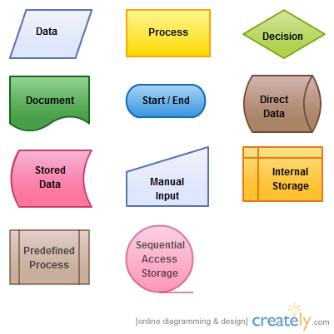](https://d3n817fwly711g.cloudfront.net/blog/wp-content/uploads/2011/11/Flowchart-Symbols1.png)

*Flowchart Symbols*

So what are the different symbols used in a flowchart?. Most people are only aware of basic symbols like processes and decision blocks. But there are much more symbols to make your flowchart more meaningful. Above image shows all the standard flowchart symbols.

The most common symbol used in a flowchart is the rectangle. A rectangle represents a process, operation or a task. The next most common symbol is the diamond which is used to represent a decision.

There are many other flowchart symbols like Sequential access storage, Direct data, Manual input etc. Check the [flowchart symbols](https://creately.com/diagram-type/objects/flowcharts) page for a detailed explanation of different symbols.

Although these are the standard symbols available in most [flowchart software](https://creately.com/Flowcharts-and-Workflow-Diagrams-Online?utm_source=flowtute&utm_medium=blog&utm_campaign=tutorialposts), some people do use different shapes for different meanings. The most common example of this is the using circles to denote start and end. The examples in this flowchart tutorial will stick with the standard symbols.

### **How to Draw a Flowchart?**

How do you draw flowchart? Well, our [flowcharting tool](https://creately.com/Flowcharts-and-Workflow-Diagrams-Online) is a good place to start. But before directly using the tool let’s take a look at some basics.

There are four main types of flowcharts. Document flowchart, System flowchart, data flowchart and program flowchart. Not everyone agrees with this categorization, but the core principals of drawing a flowchart remain the same. You need to consider few things when drawing a flowchart, Check out [6 useful tips on drawing flowcharts](https://creately.com/diagram-type/article/6-useful-tips-drawing-flowcharts) before you start.

If you are drawing a flowchart with many responsible parties, you can group them together using swim lanes. Swim lanes are a powerful technique to increase the readability of you flowchart so you should use them according to the situation. Read [using swim lanes in flowcharts](https://creately.com/diagram-type/article/swim-lanes-mapping-processes) to learn more about the process.

Below video shows how to draw a flowchart using Creately. It is very simple to use and one click create and connect helps you draw them faster as well. You can drag and drop symbols from the library or drag images to your diagram by doing an image search.

### **Flowchart Templates and Examples**

Although you can start drawing flowcharts by scratch it is much easier to use templates. They help you reduce errors and reminds you about the best practices to follow. If you want to use a ready-made template, go to [flowchart examples section](https://creately.com/diagram-community/examples/t/flowchart?utm_source=flowtute&utm_medium=blog&utm_campaign=tutorialposts) and click on the flowchart that best suits you. Click on the use at template after the image and you are ready to draw your flowchart.

Below are two templates out of [hundreds of flowchart templates](https://creately.com/diagram-type/templates/flowcharts?utm_source=flowtute&utm_medium=blog&utm_campaign=tutorialposts) available to the user. Click on any of them to start drawing flowcharts immediately.

[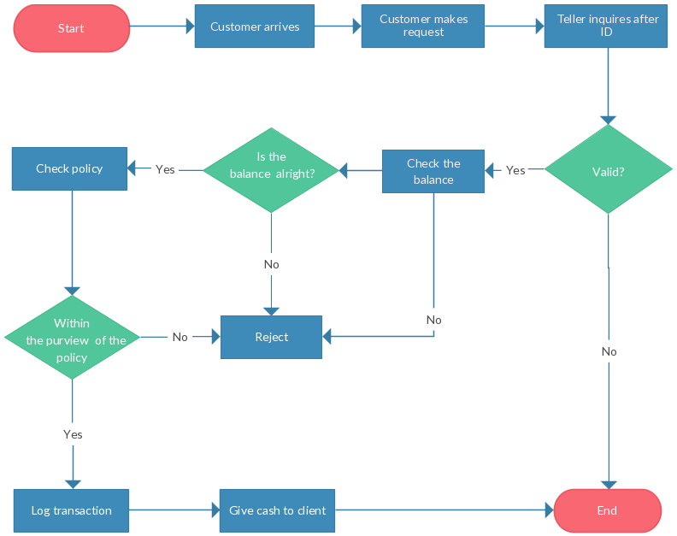](https://creately.com/creately-start?tempID=gmd8bbfk2&utm_source=flowtute&utm_medium=blog&utm_campaign=tutorialposts)

*Support Process Flowchart Template*

[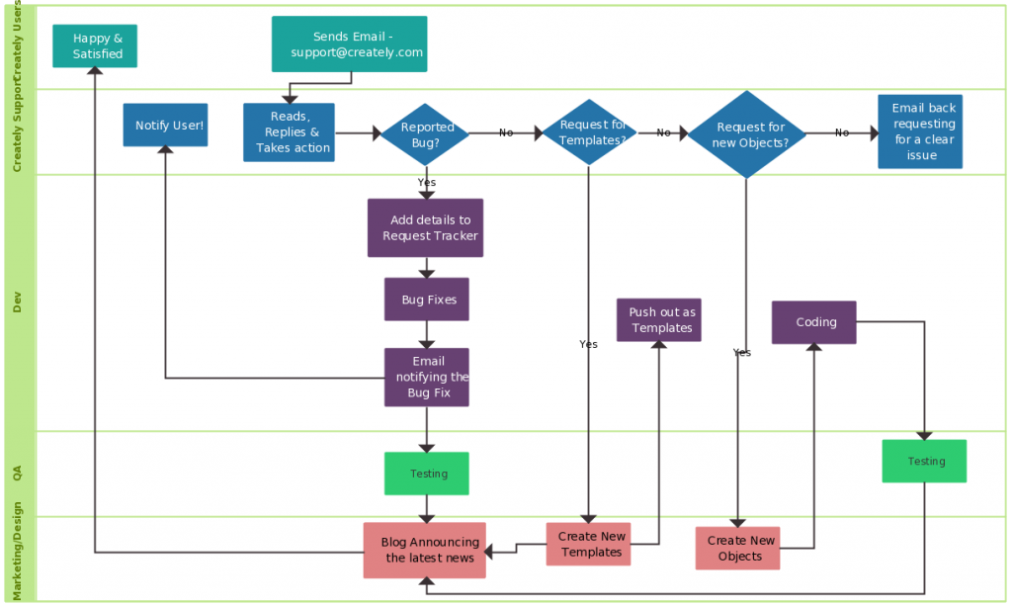](https://creately.com/creately-start?tempID=geu4qzpa5&utm_source=flowtute&utm_medium=blog&utm_campaign=tutorialposts)

*Support Process Flowchart Template*

### **Flowchart Best Practices**

There are few things you can do to make your flowchart universally accepted. And there are some things that you can do to make it visually pleasing to others as well.

If you’re planning to share your flowchart or hoping to use it one presentation etc. then it’s wise to use standard symbols. However, it is important to remember that the idea is to give out information in an easy to understand manner. It is perfectly acceptable to use an alternative image instead of the document symbol as long as the audience understands it.

Keeping the arrow flow to one side, using same size symbols, naming the decision blocks, processes, arrows etc. are few things you can do to make it better. The common mistakes section covers most of these practices in detail.

### **Common Mistakes Made when Drawing Flowcharts**

This section highlights the common mistakes made when drawing flowcharts. Some of the things mentioned here are to make it better looking and more understandable, not having them in your flowchart won’t make it wrong. Since there are two posts covering these mistakes in depth I will link to them from this flowchart tutorial.

[15 mistakes you would unintentionally make with flowcharts ( Part 1 )](https://creately.com/blog/diagrams/part-1-15-mistakes-you-would-unintentionally-make-with-flowcharts/)

[15 mistakes you would unintentionally make with flowcharts ( Part 2 )](https://creately.com/blog/diagrams/part-2-15-mistakes-you-would-unintentionally-make-with-flowcharts/)

### **Effective Use of Flowcharts – Case Studies**

A flowchart tutorial isn’t complete without some case studies. Below are three case studies and real life examples on how flowcharts can help you make decisions.

* [Ten Flowchart Ideas for Your Business](https://creately.com/blog/diagrams/top-10-flowchart-ideas-for-your-small-business/) – How flowcharts can be used in making business decision and to optimize the current business processes
* [Analyzing Sales Funnel with Flowcharts](https://creately.com/diagram-type/usage/analyzing-sales-funnel-flowcharts) – How to analyze the Google analytic sales funnel using a flowchart.
* [Flutterscape Case Study](https://creately.com/diagram-type/usage/case-study-flutterscape) – How one of our customers used flowcharts to enhance their processes.

### **Frequently Asked Questions About Flowchart**

The comments section of this article is full of questions. Please note that I will not draw flowcharts for specific scenarios. Below I have answered some of the most frequently asked questions.

**Q 01**: What is a sub process in a flowchart?

Answer: Sometimes complex processes are broken down into smaller sub-processes for clarity. So a flowchart can point to a different sub process within its flow. The predefined process symbol is used to show such sub processes.

**Q 02**: How are flowcharts used in computer programming?

Answer: A computer program consists many processes and flows. Flowcharts are used to visualize the processes and make it understandable for nontechnical people. They are also used to visualize algorithms and comprehend pseudo code which is used in programming.

### **Comments and Feedback on the Flowchart Tutorial**

I hope this flowchart tutorial will help you to come up with awesome flowcharts. Flowcharts are a great way present complex processes in a simple to understand manner and they are used all over the world in many industries. If you have a question about drawing flowcharts or have any suggestions to improve this post, feel free to mention in the comments section.

### **More Diagram Tutorials**

* [Sequence Diagram Tutorial: Complete Guide with Examples](https://creately.com/blog/diagrams/sequence-diagram-tutorial/)
* [Business Process Modeling Tutorial (BPM Guide Explaining Features)](https://creately.com/blog/diagrams/business-process-modeling-tutorial/)
* [Use Case Diagram Tutorial ( Guide with Examples )](https://creately.com/blog/diagrams/use-case-diagram-tutorial/)